ultramirinc.champs_mood.models

Class Break

java.lang.Object ultramirinc.champs_mood.models.Break

All Implemented Interfaces:

java.lang.Comparable<Break>



public class Break extends java.lang.Object

implements java.lang.Comparable<Break>

Created by Etienne Berube on 2017­03­28. This is the object that contains all the information and methods for a Break

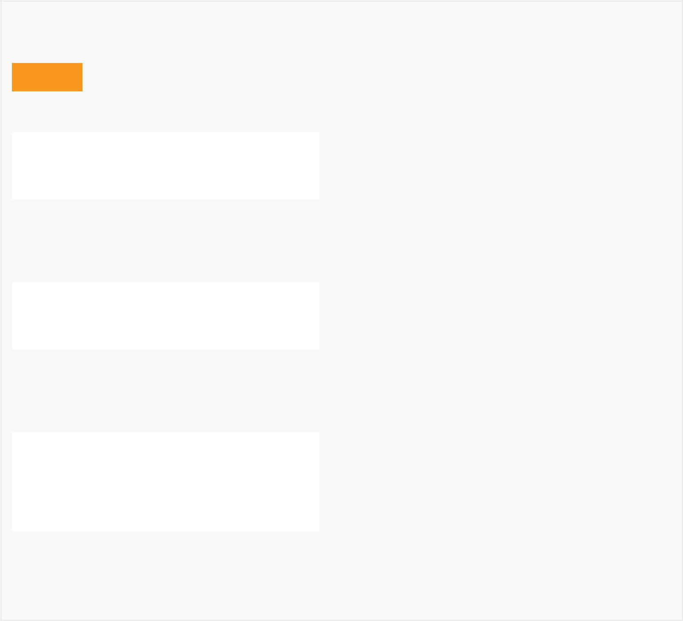

*Field Summary*

Fields

|  |  |  |  |
| --- | --- | --- | --- |
|  | Modifier and Type | Field and |  |
|  |  | Description |  |
|  | private java.lang.String | day |  |
|  |  | The day of the |  |
|  |  | break |  |
|  |  |  |  |
|  | private Time | end |  |
|  |  | Contains the |  |
|  |  | at which the |  |
|  |  | break ends |  |
|  | private java.lang.String | Id |  |
|  |  | The Id of the |  |
|  |  | Break |  |
|  |  |  |  |
|  | private int | intDay |  |
|  |  | The integer |  |
|  |  | representation |  |
|  |  | of the day |  |
|  | private Time | start |  |
|  |  | Contains the |  |
|  |  | time at which |  |
|  |  | the break |  |
|  |  | starts |  |
|  |  |  |  |
|  | private java.lang.String | userId |  |
|  |  | The user's ID |  |
|  |  | in the |  |
|  |  | database |  |
|  |  |  |  |
|  |  |  |  |

*Constructor Summary*

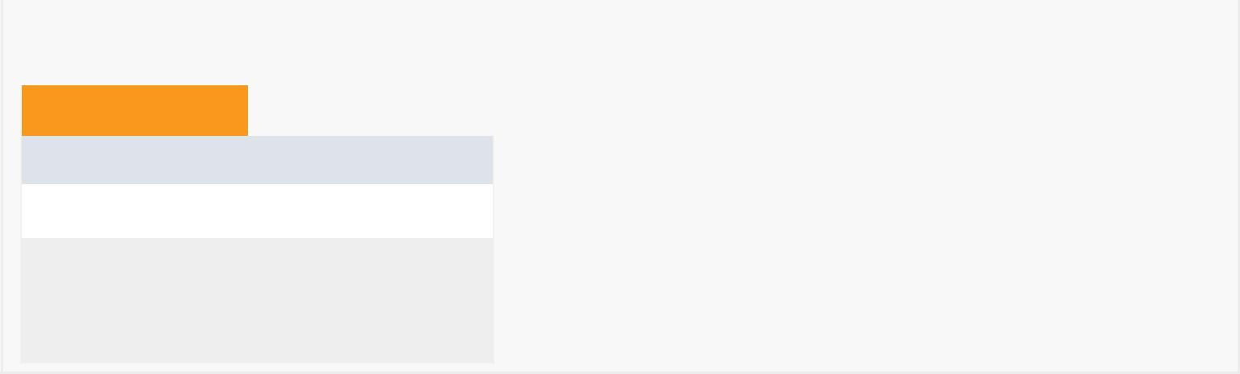

Constructors

Constructor and Description

Break()

Break(Time start, Time end, java.lang.String day, java.lang.String relatedUserId)



*Method Summary*

|  |  |  |  |  |  |  |  |
| --- | --- | --- | --- | --- | --- | --- | --- |
|  | All Methods |  |  | [Instance Methods](javascript:show(2);) | | |  |
|  | [Concrete Methods](javascript:show(8);) | | | | |  | |
|  | Modifier and Type | | |  | Method and Description | | |
|  | int | | |  | compareTo(Break o) | | |
|  |  |  |  |  | Determines is a break is before or after | | |
|  |  |  |  |  | another break. | | |
|  |  |  |  |  |  |  |  |
|  | boolean | | |  | equals(java.lang.Object o) | | |
|  |  |  |  |  | Returns whether or not two breaks are | | |
|  |  |  |  |  | the same. | | |
|  | java.lang.String | | | | getDay() | | |
|  |  |  |  |  | Getter for the day. | | |
|  |  |  |  |  |  |  |  |
|  | Time | | |  | getEnd() | | |
|  |  |  |  |  | Getter for the end time. | | |
|  | java.lang.String | | | | getFromTime() | | |
|  |  |  |  |  | Returns a string interpretation of the | | |
|  |  |  |  |  | starting time. | | |
|  |  |  |  | |  |  |  |
|  | java.lang.String | | | | getId() | | |
|  |  |  |  |  | Getter for ID. | | |
|  | int | | |  | getIntDay() | | |
|  |  |  |  |  | Getter for the integer representation of | | |
|  |  |  |  |  | the day. | | |
|  |  |  |  |  |  |  |  |
|  | Time | | |  | getStart() | | |
|  |  |  |  |  | Getter for the starting time. | | |
|  | Time | | |  | getTimeDifference() | | |
|  |  |  |  |  | Returns the time difference between two | | |
|  |  |  |  |  | breaks. | | |
|  |  |  |  | |  |  |  |
|  | java.lang.String | | | | getToTime() | | |
|  |  |  |  |  | Returns a string interpretation of the | | |
|  |  |  |  |  | ending time. | | |
|  |  |  |  |  |  |  |  |

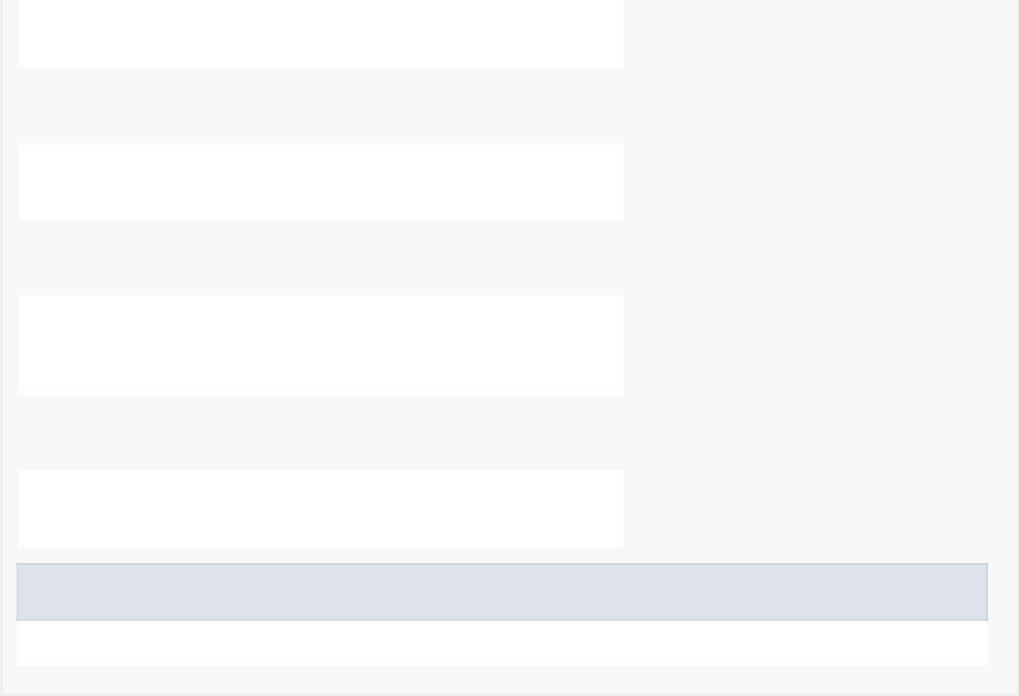

|  |  |
| --- | --- |
| java.lang.String | getUserId() |
|  | Getter for the UserID |
|  |  |
| void | setDay(java.lang.String day) |
|  | Setter for the day. |
| void | setEnd(Time end) |
|  | Setter for the end time. |
|  |  |
| void | setId(java.lang.String id) |
|  | Setter for ID. |
| void | setIntDay(int intDay) |
|  | Setter for the integer representation of |
|  | the day. |
|  |  |
| void | setStart(Time start) |
|  | Setter for the starting time. |
| void | setUserId(java.lang.String userId) |
|  | Setter for the the UserID |
|  |  |

Methods inherited from class java.lang.Object

clone, finalize, getClass, hashCode, notify, notifyAll, toString, wait, wait, wait

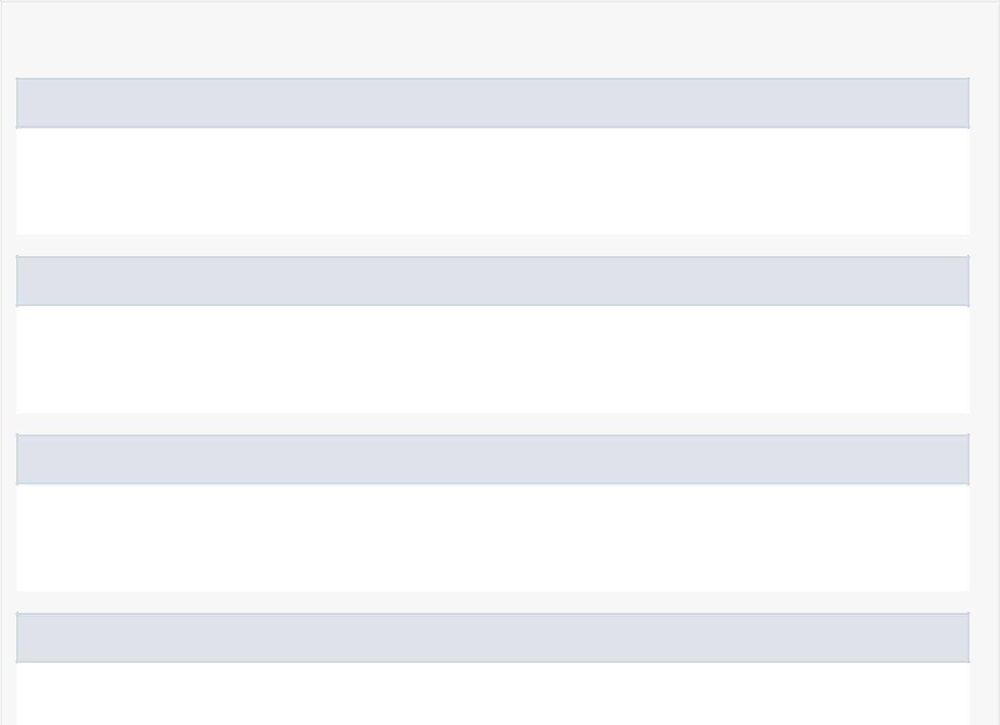

*Field Detail*

start

private Time start

Contains the time at which the break starts

end

private Time end

Contains the at which the break ends

day

private java.lang.String day

The day of the break

userId

private java.lang.String userId

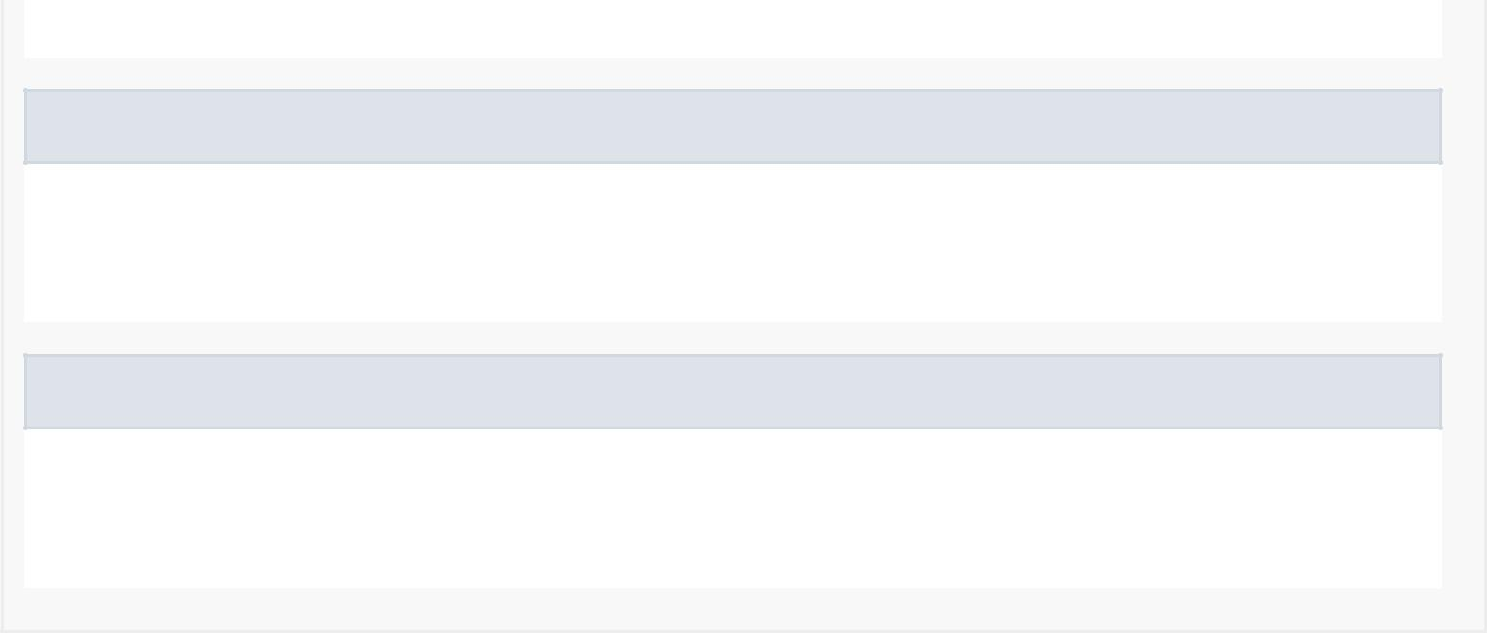The user's ID in the database

intDay

private int intDay

The integer representation of the day

Id

private java.lang.String Id

The Id of the Break

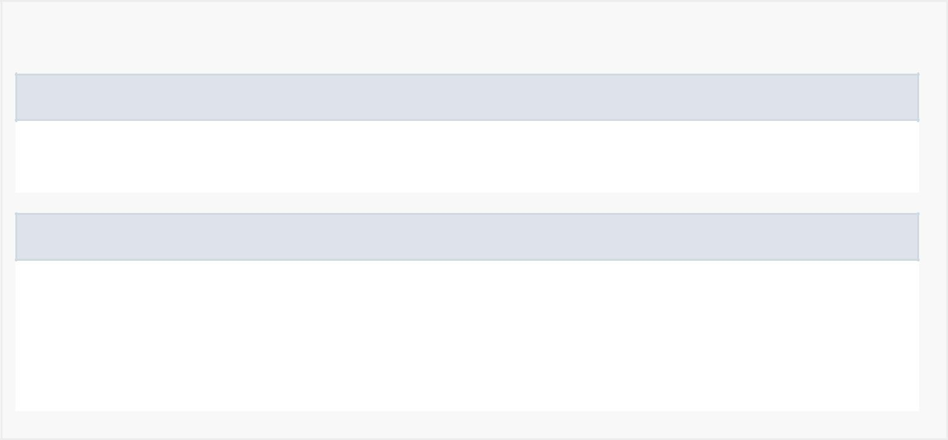

*Constructor Detail*

Break

public Break()

Break

public Break(Time start, Time end,

java.lang.String day, java.lang.String relatedUserId)

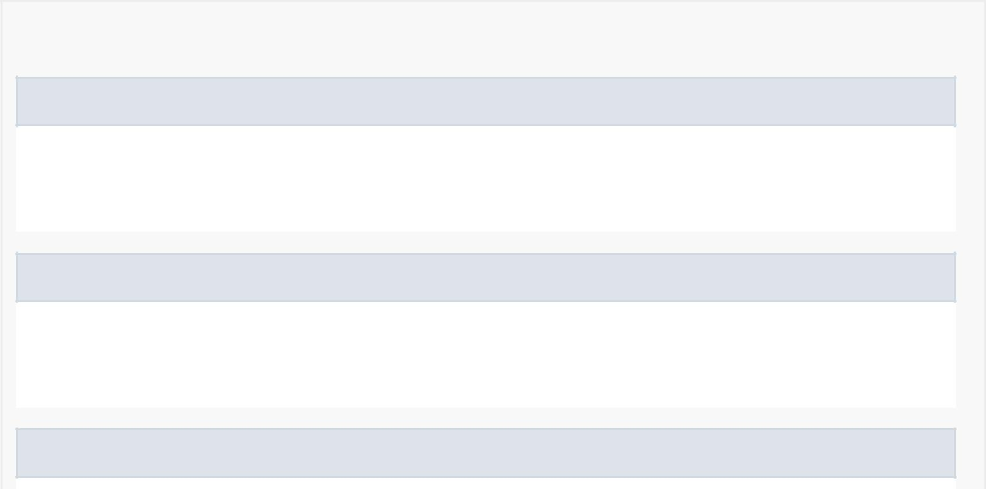

*Method Detail*

setId

public void setId(java.lang.String id)

Setter for ID.

getId

public java.lang.String getId()

Getter for ID.

getStart

public Time getStart()

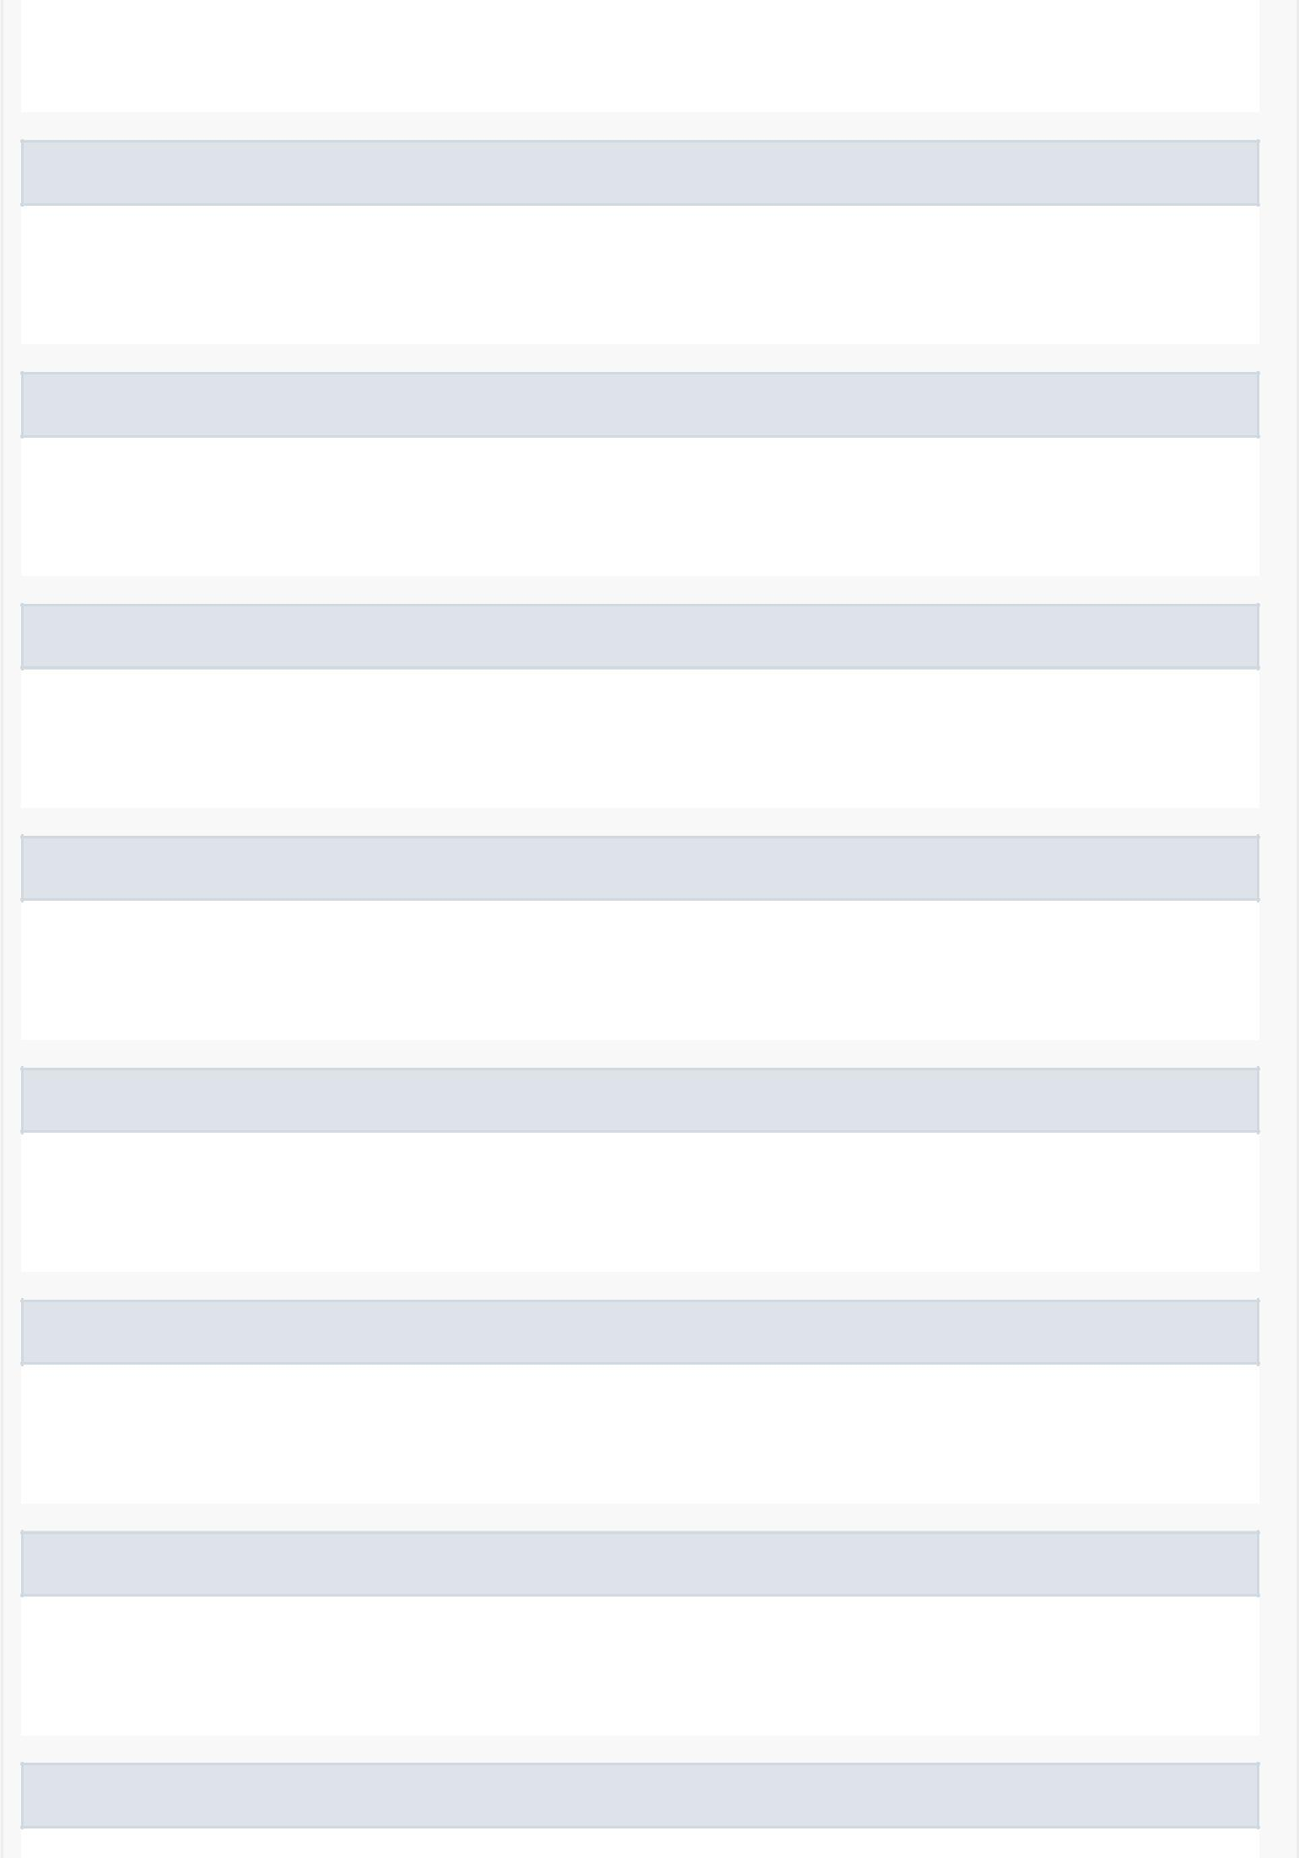

Getter for the starting time.

setStart

public void setStart(Time start)

Setter for the starting time.

getFromTime

public java.lang.String getFromTime()

Returns a string interpretation of the starting time.

getEnd

public Time getEnd()

Getter for the end time.

setEnd

public void setEnd(Time end)

Setter for the end time.

getToTime

public java.lang.String getToTime()

Returns a string interpretation of the ending time.

getDay

public java.lang.String getDay()

Getter for the day.

setDay

public void setDay(java.lang.String day)

Setter for the day.

getIntDay

public int getIntDay()

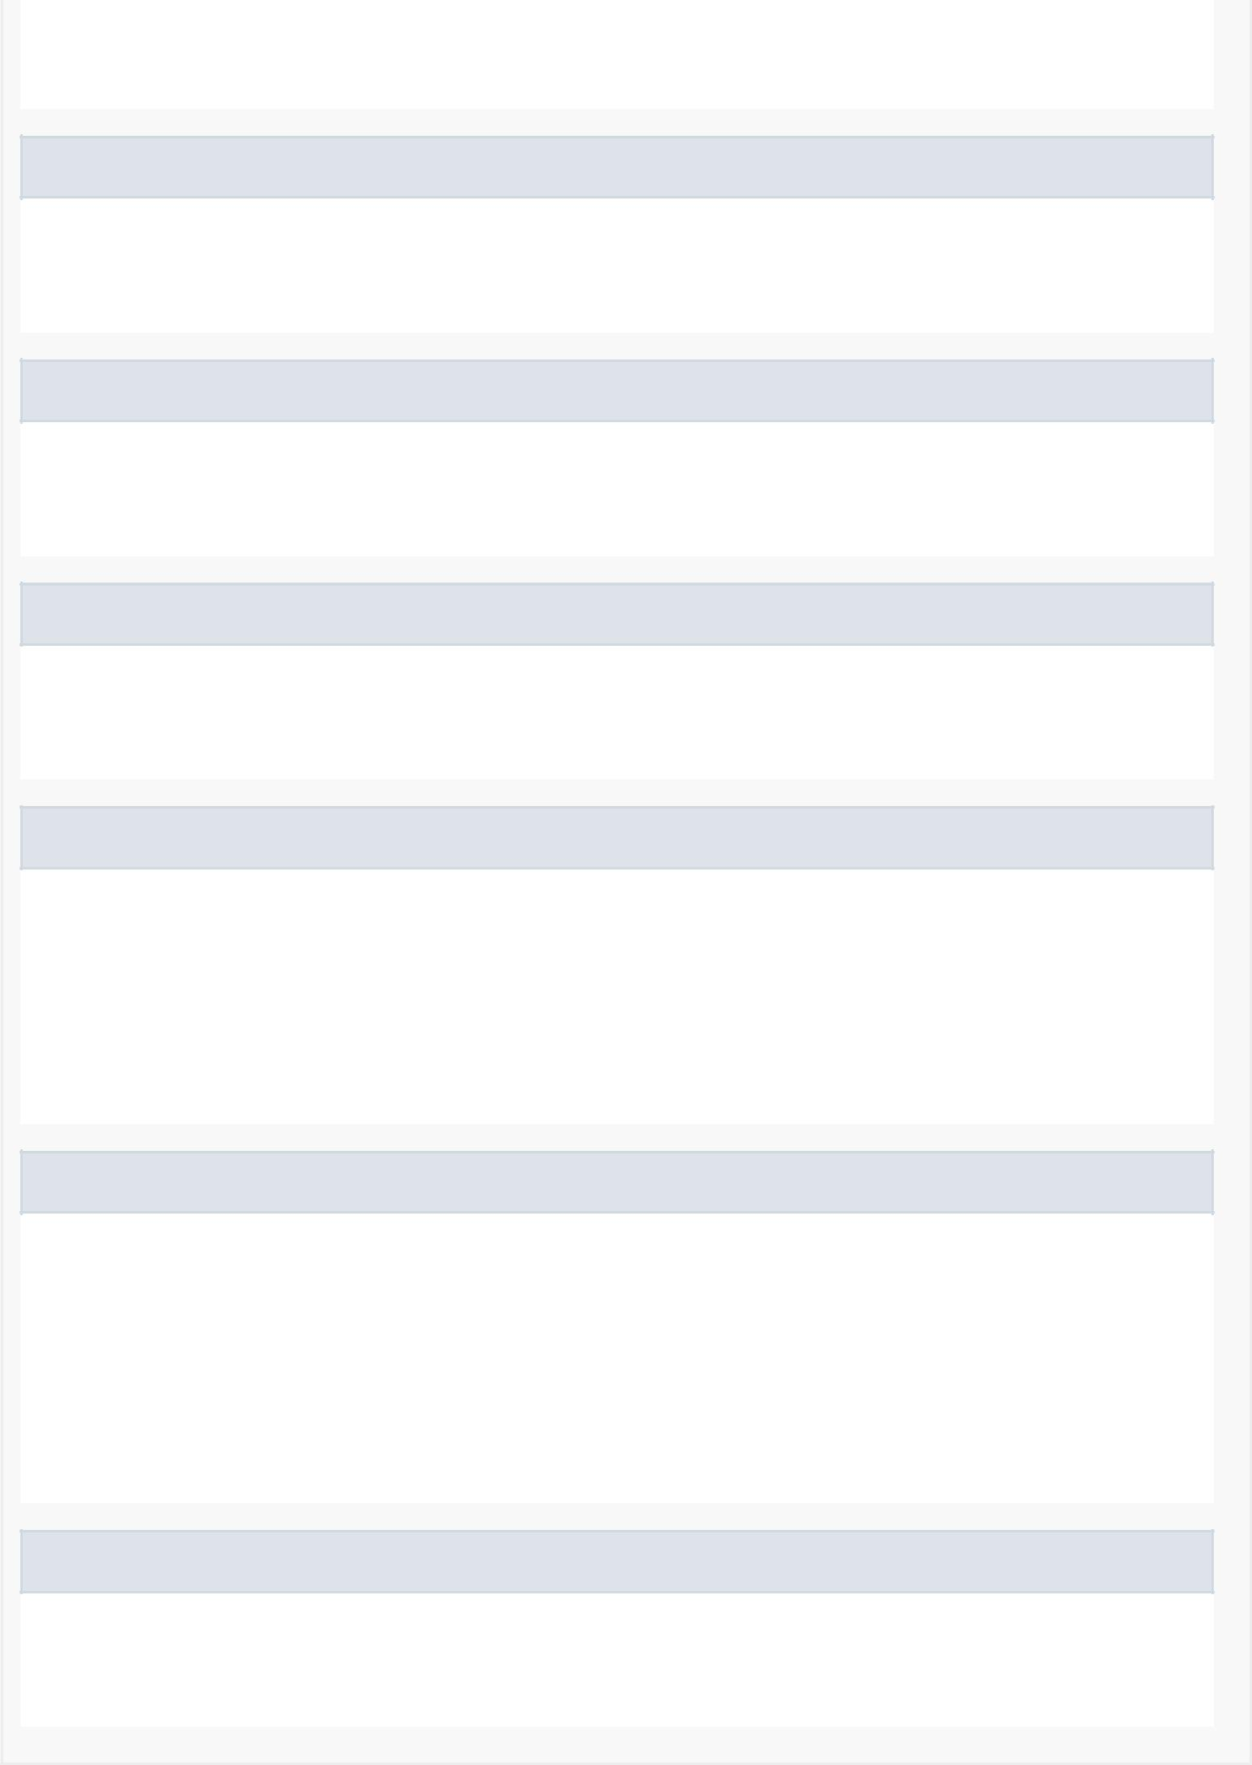

Getter for the integer representation of the day.

setIntDay

public void setIntDay(int intDay)

Setter for the integer representation of the day.

getUserId

public java.lang.String getUserId()

Getter for the UserID

setUserId

public void setUserId(java.lang.String userId)

Setter for the the UserID

equals

public boolean equals(java.lang.Object o)

Returns whether or not two breaks are the same.

Overrides:

equals in class java.lang.Object

compareTo

public int compareTo(@NonNull Break o)

Determines is a break is before or after another break.

Specified by:

compareTo in interface java.lang.Comparable<Break>

getTimeDifference

public Time getTimeDifference()

Returns the time difference between two breaks.